Intro to SQL Commands - Administrative Commands

✅ What Are SQL Administrative Commands?
# Source: AI Source: Provided by: [Data Path: Persons Table -> ID Column: 1, Name_En Column: Motasem Essam] -> From: [ChatGPT] on [6/11/2026]
SQL Administrative Commands are commands used to manage and maintain the database environment, rather than to manipulate or query data directly. These commands are typically outside the standard SQL categories (DDL, DML, etc.) and are specific to database systems like SQL Server, MySQL, or Oracle.

🛠️ Common SQL Administrative Tasks & Commands
# Source: AI Source: Provided by: [Data Path: Persons Table -> ID Column: 1, Name_En Column: Motasem Essam] -> From: [ChatGPT] on [6/11/2026]
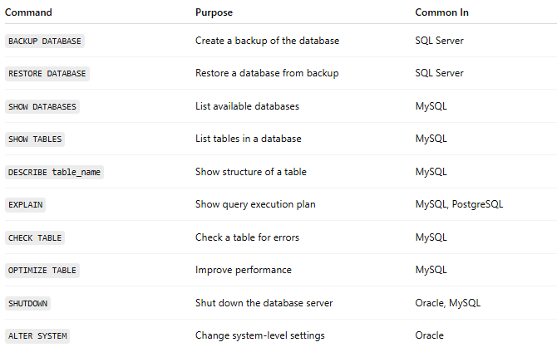
Command | Purpose | Common In
BACKUP DATABASE | Create a backup of the database | SQL Server
RESTORE DATABASE | Restore a database from backup | SQL Server
SHOW DATABASES | List available databases | MySQL
SHOW TABLES | List tables in a database | MySQL
DESCRIBE table_name | Show structure of a table | MySQL
EXPLAIN | Show query execution plan | MySQL, PostgreSQL
CHECK TABLE | Check a table for errors | MySQL
OPTIMIZE TABLE | Improve performance | MySQL
SHUTDOWN | Shut down the database server | Oracle, MySQL
ALTER SYSTEM | Change system-level settings | Oracle

📌 Notes:
# Source: AI Source: Provided by: [Data Path: Persons Table -> ID Column: 1, Name_En Column: Motasem Essam] -> From: [ChatGPT] on [6/11/2026]
- These commands are often vendor-specific.
- They require admin privileges.
- Not all databases support all commands (e.g., BACKUP DATABASE is not valid in MySQL, but is in SQL Server).

SQL Administrative Commands organized by major database systems
# Source: AI Source: Provided by: [Data Path: Persons Table -> ID Column: 1, Name_En Column: Motasem Essam] -> From: [ChatGPT] on [6/11/2026]
Great! Here's a curated list of SQL Administrative Commands organized by major database systems, perfect for your new folder:
📁 7 - SQL Administrative Commands

✅ 1. SQL Server (T-SQL)
# Source: AI Source: Provided by: [Data Path: Persons Table -> ID Column: 1, Name_En Column: Motasem Essam] -> From: [ChatGPT] on [6/11/2026]
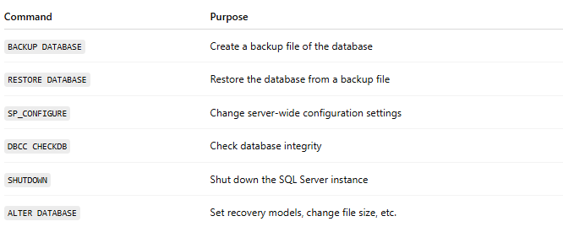
Command | Purpose
BACKUP DATABASE | Create a backup file of the database
RESTORE DATABASE | Restore the database from a backup file
SP_CONFIGURE | Change server-wide configuration settings
DBCC CHECKDB | Check database integrity
SHUTDOWN | Shut down the SQL Server instance
ALTER DATABASE | Set recovery models, change file size, etc.

✅ 2. MySQL
# Source: AI Source: Provided by: [Data Path: Persons Table -> ID Column: 1, Name_En Column: Motasem Essam] -> From: [ChatGPT] on [6/11/2026]
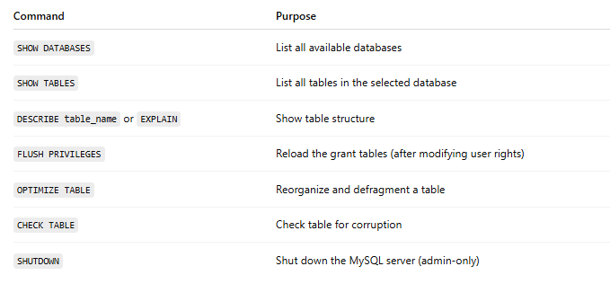
Command | Purpose
SHOW DATABASES | List all available databases
SHOW TABLES | List all tables in the selected database
DESCRIBE table_name or EXPLAIN | Show table structure
FLUSH PRIVILEGES | Reload the grant tables (after modifying user rights)
OPTIMIZE TABLE | Reorganize and defragment a table
CHECK TABLE | Check table for corruption
SHUTDOWN | Shut down the MySQL server (admin-only)

✅ 3. PostgreSQL
# Source: AI Source: Provided by: [Data Path: Persons Table -> ID Column: 1, Name_En Column: Motasem Essam] -> From: [ChatGPT] on [6/11/2026]
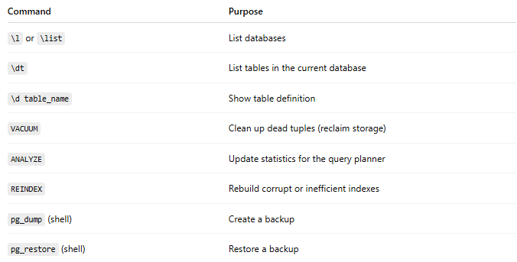
Command | Purpose
\l or \list | List databases
\dt | List tables in the current database
\d table_name | Show table definition
VACUUM | Clean up dead tuples (reclaim storage)
ANALYZE | Update statistics for the query planner
REINDEX | Rebuild corrupt or inefficient indexes
pg_dump (shell) | Create a backup
pg_restore (shell) | Restore a backup

✅ 4. Oracle
# Source: AI Source: Provided by: [Data Path: Persons Table -> ID Column: 1, Name_En Column: Motasem Essam] -> From: [ChatGPT] on [6/11/2026]

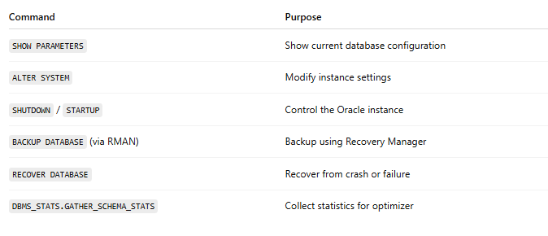
Command | Purpose
SHOW PARAMETERS | Show current database configuration
ALTER SYSTEM | Modify instance settings
SHUTDOWN / STARTUP | Control the Oracle instance
BACKUP DATABASE (via RMAN) | Backup using Recovery Manager
RECOVER DATABASE | Recover from crash or failure
DBMS_STATS.GATHER_SCHEMA_STATS | Collect statistics for optimizer

📘 Bonus: Cross-System Useful Shell Commands (not SQL but often used)
# Source: AI Source: Provided by: [Data Path: Persons Table -> ID Column: 1, Name_En Column: Motasem Essam] -> From: [ChatGPT] on [6/11/2026]
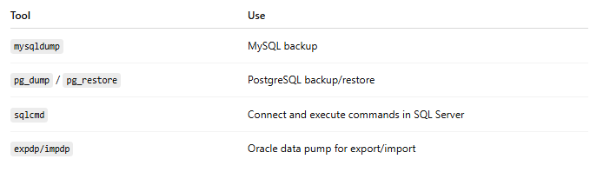
Tool | Use
mysqldump | MySQL backup
pg_dump / pg_restore | PostgreSQL backup/restore
sqlcmd | Connect and execute commands in SQL Server
expdp/impdp | Oracle data pump for export/import

📂 Suggested Folder Structure Example:
# Source: AI Source: Provided by: [Data Path: Persons Table -> ID Column: 1, Name_En Column: Motasem Essam] -> From: [ChatGPT] on [6/11/2026]

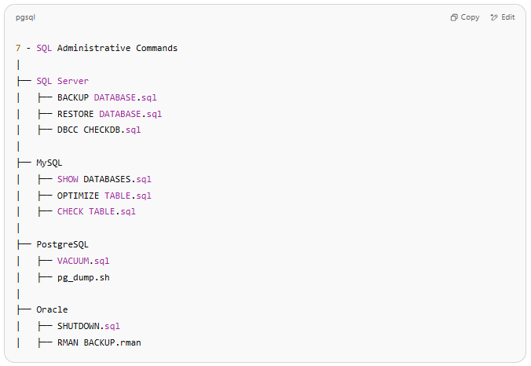
7 - SQL Administrative Commands
│
├── SQL Server
│ ├── BACKUP DATABASE.sql
│ ├── RESTORE DATABASE.sql
│ ├── DBCC CHECKDB.sql
│
├── MySQL
│ ├── SHOW DATABASES.sql
│ ├── OPTIMIZE TABLE.sql
│ ├── CHECK TABLE.sql
│
├── PostgreSQL
│ ├── VACUUM.sql
│ ├── pg_dump.sh
│
├── Oracle
│ ├── SHUTDOWN.sql
│ ├── RMAN BACKUP.rman

💡 Summary:
# Source: AI Source: Provided by: [Data Path: Persons Table -> ID Column: 1, Name_En Column: Motasem Essam] -> From: [ChatGPT] on [6/11/2026]
SQL Administrative Commands help manage the database as a whole, not just the data or structure inside it.

